Navigate to Database and select RDS

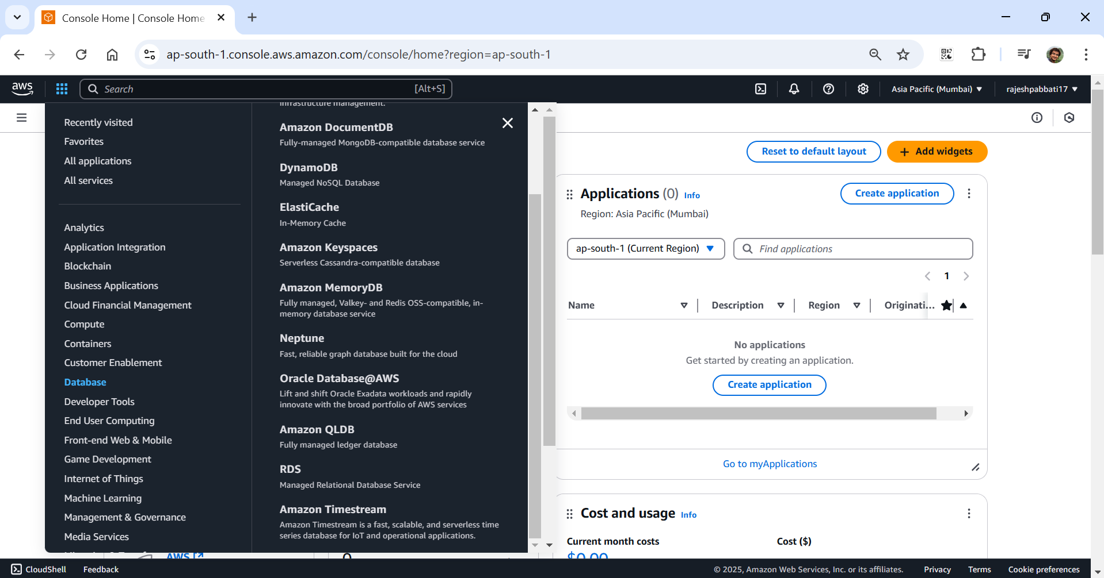

Click on Databases

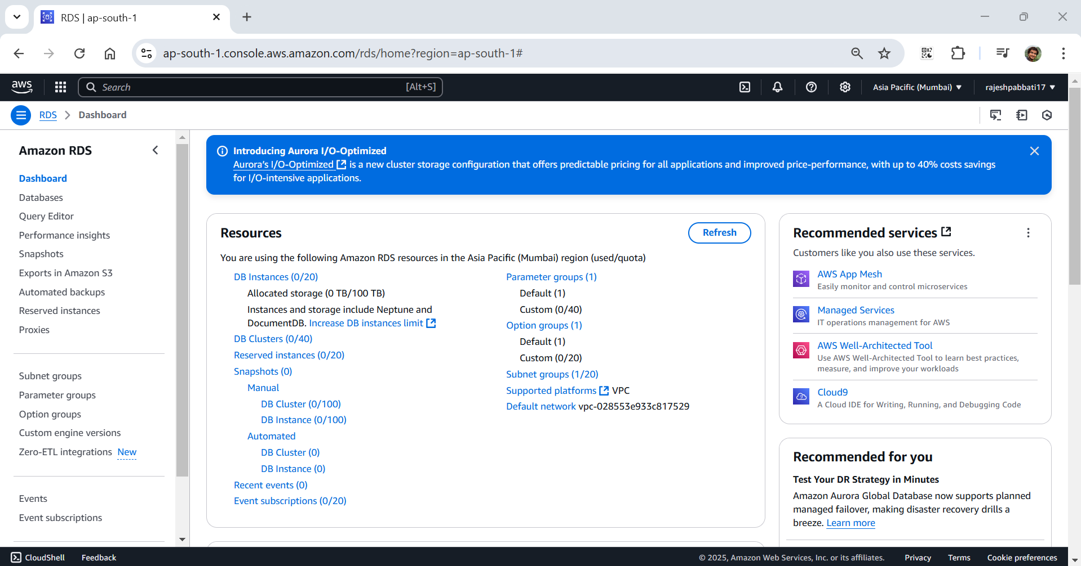

Click on Create database

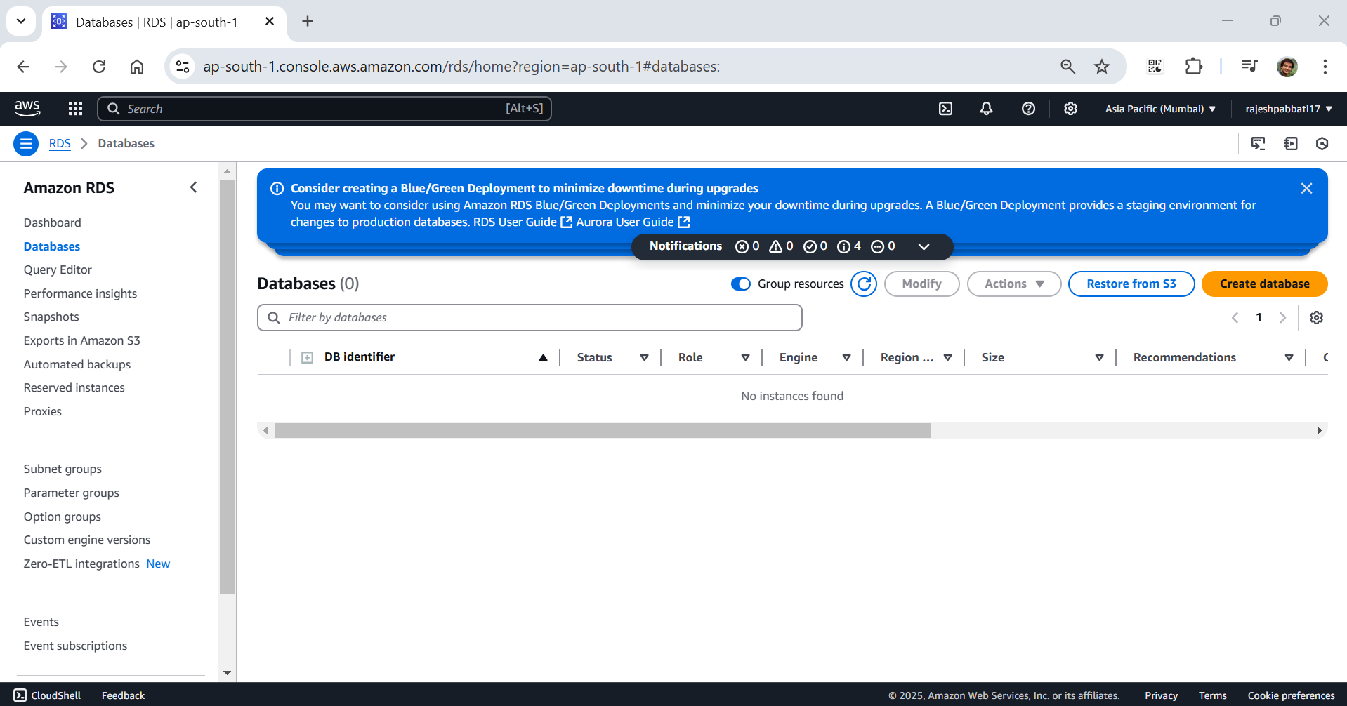

Select Standard create and Engine options MySQL

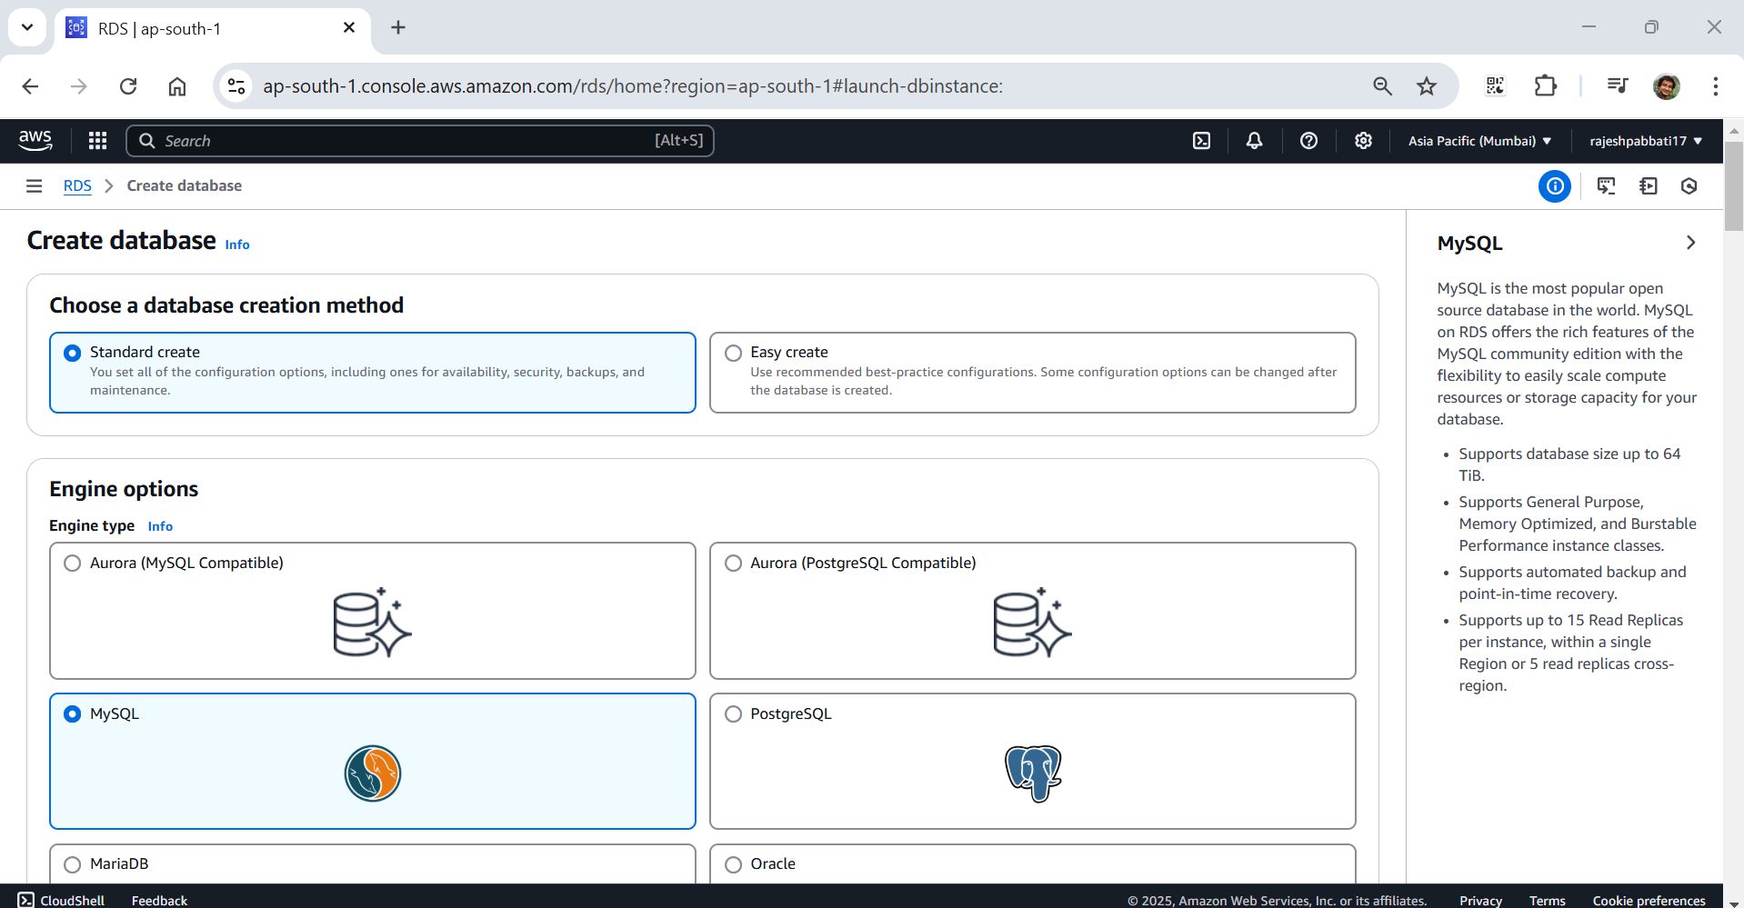

Select Templates Free tier and give DB Instnaces identifier for example demo-database

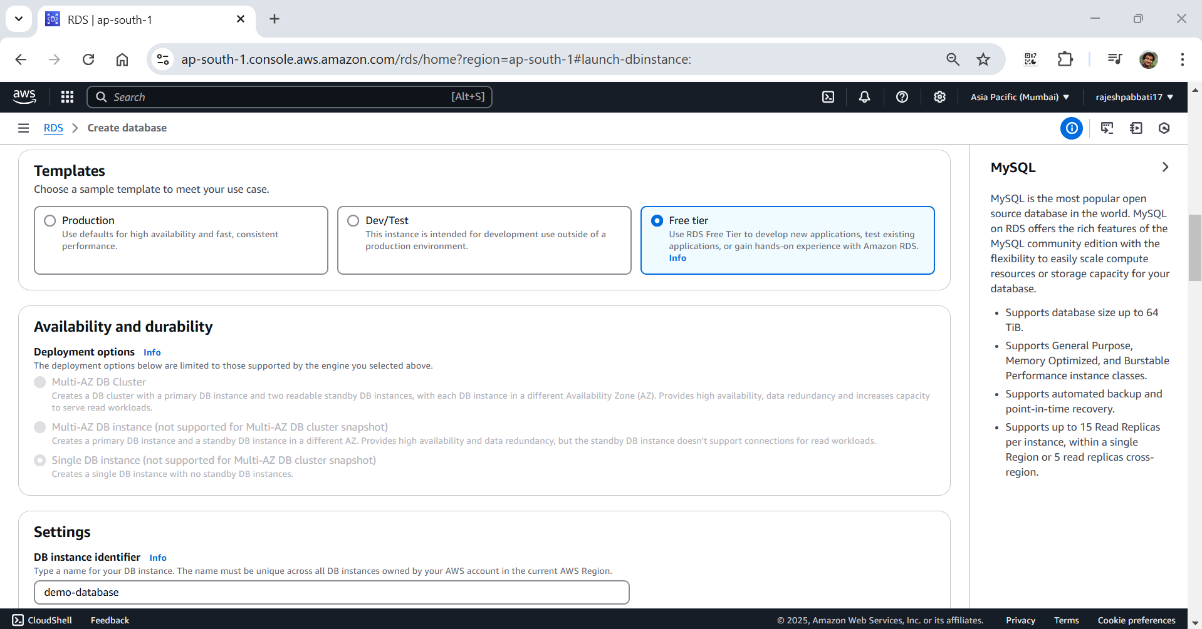

Select Credentials management as Self managed and give password

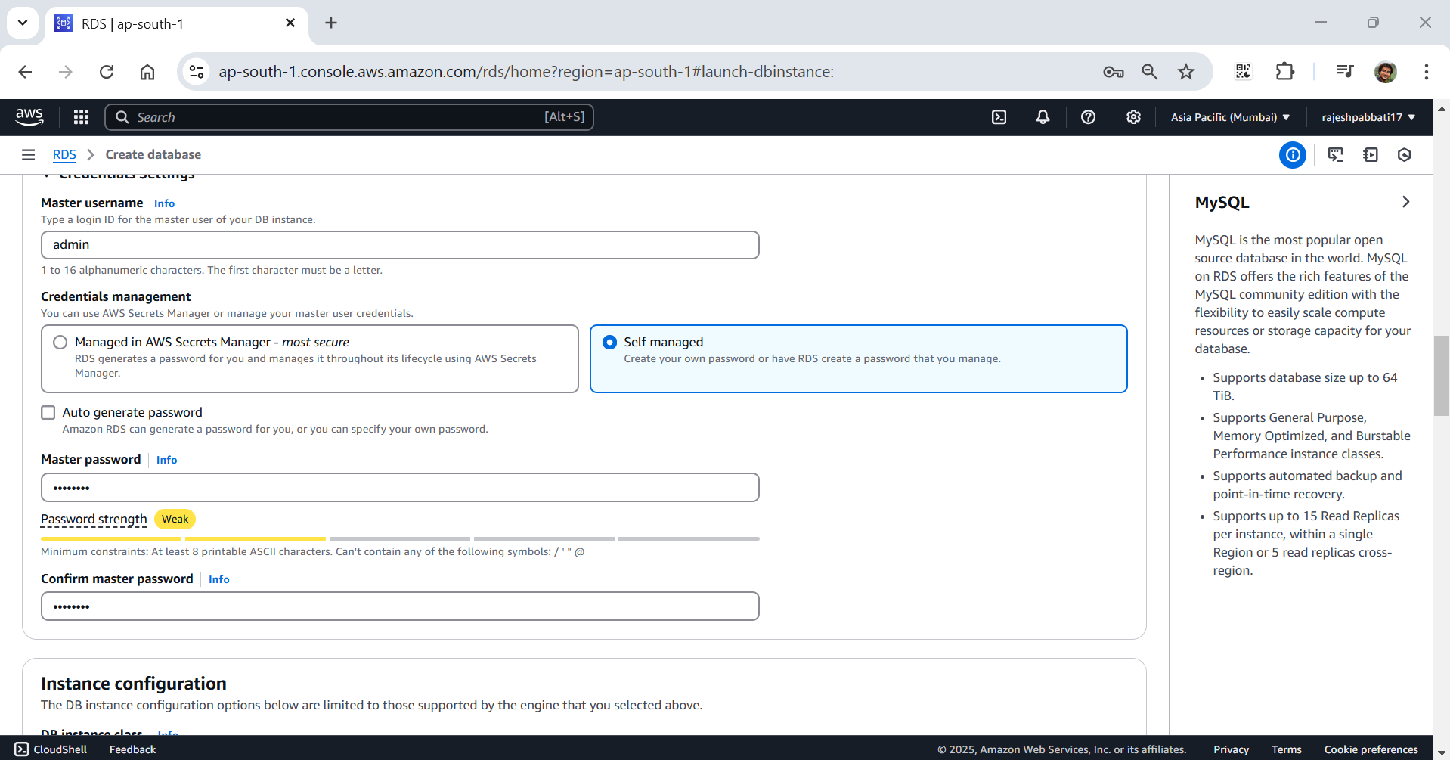

Delst db.t3.micro

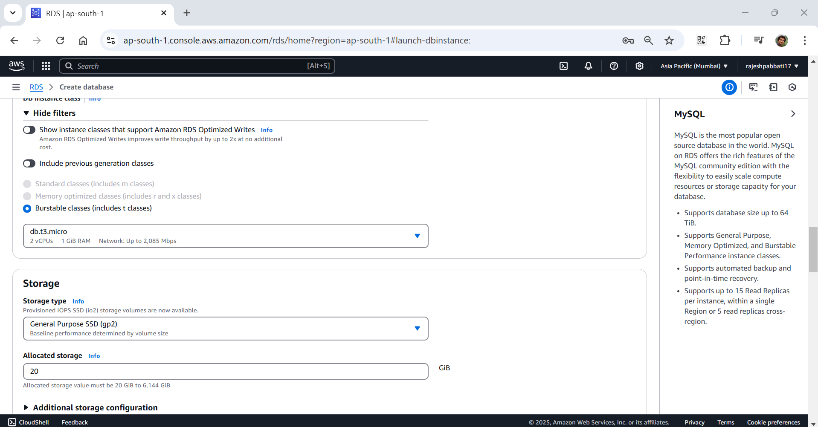

Select default VPC and DB subnet group and give public access yes

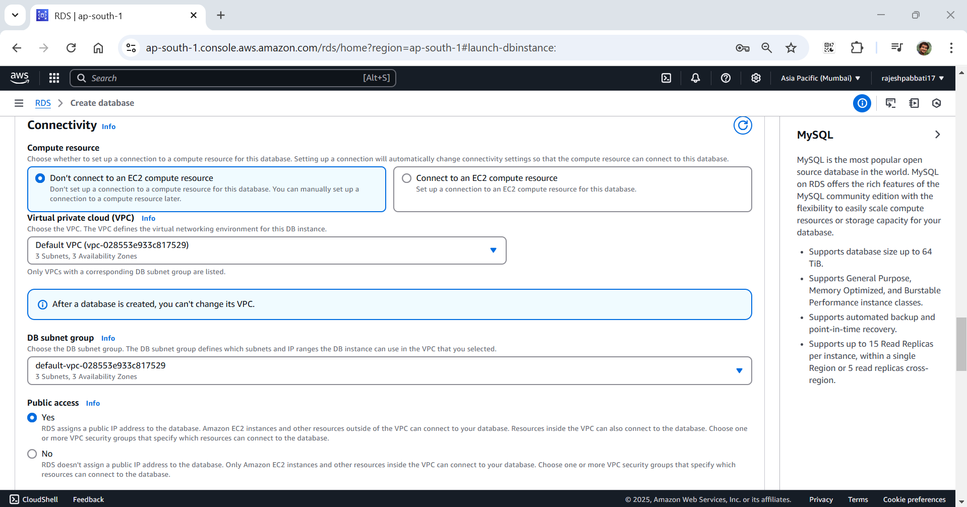

Give default settings for VPC security group, and availability zone

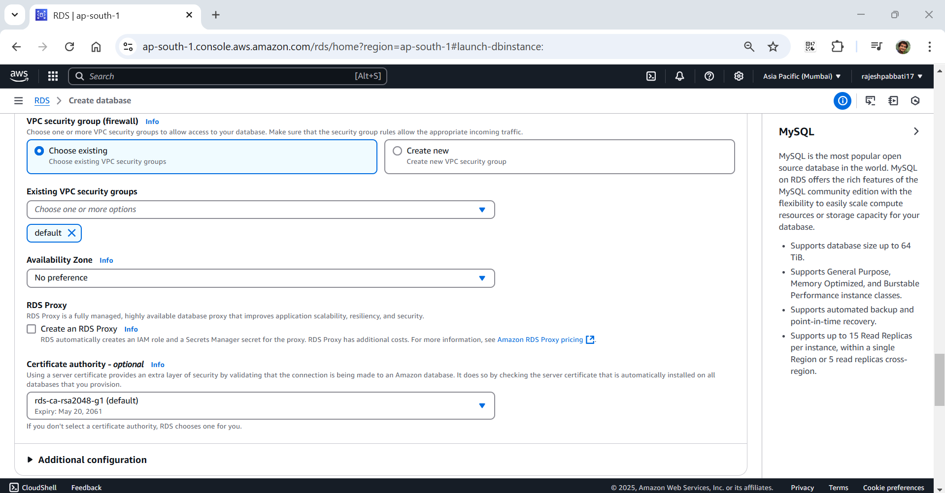

Remove Monitoring tick mark and click on Additional configuration

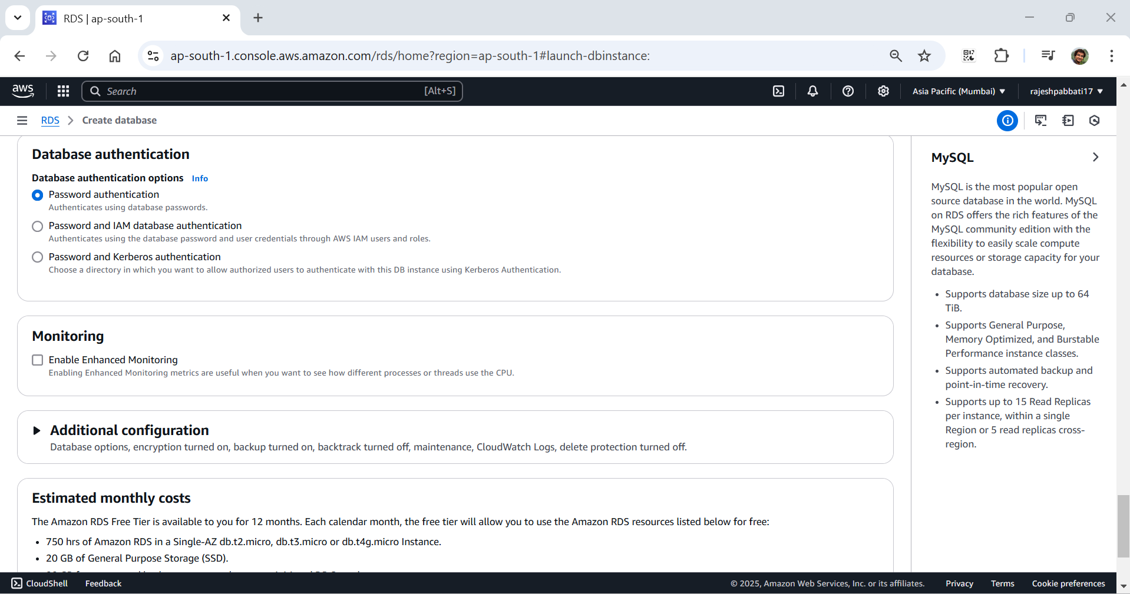

In additional configuration uncheck Enable automated backups and Enable encryption

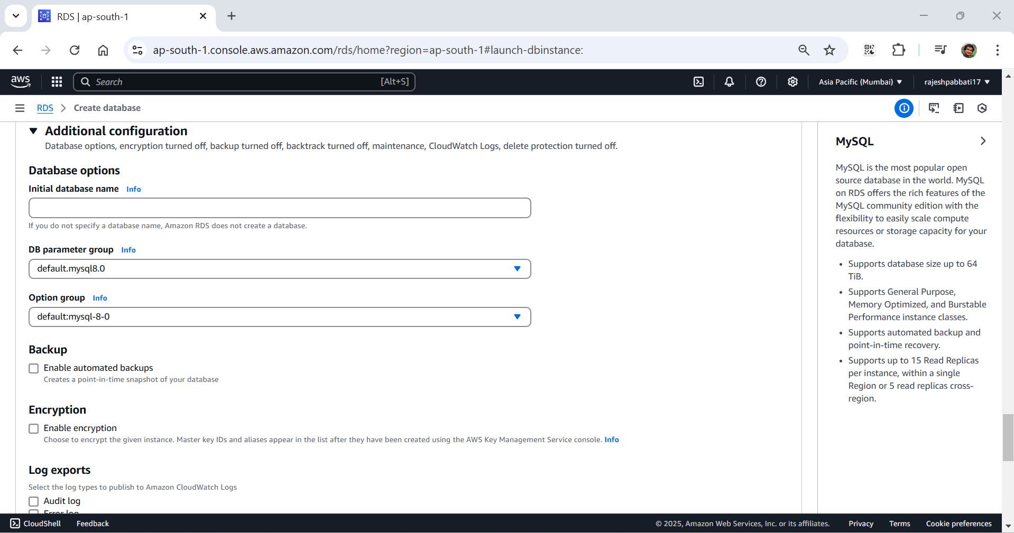

Under maintenance uncheck Enable auto minor version upgrade

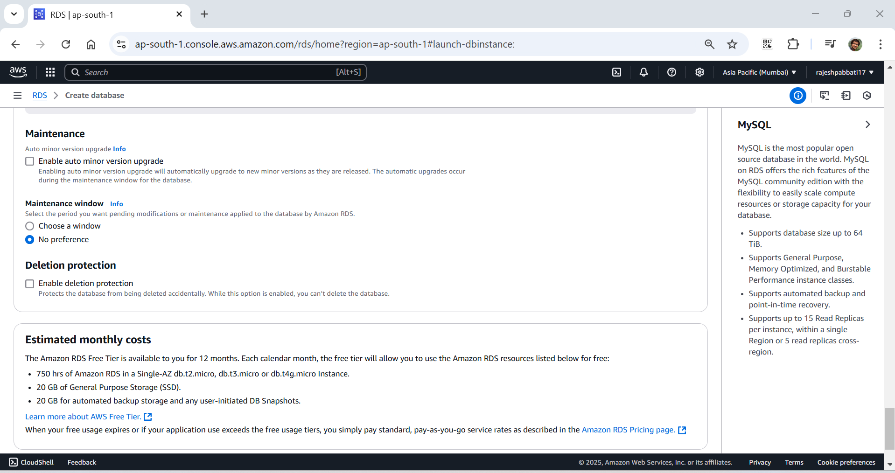

Click on Create database

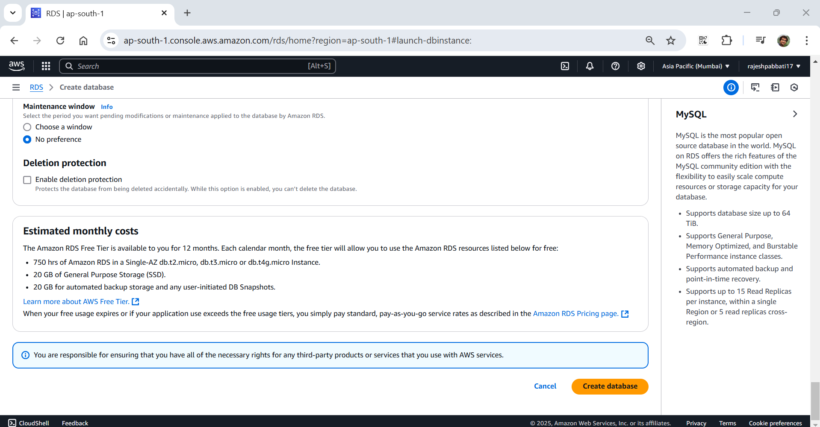

Click close if pop came like this

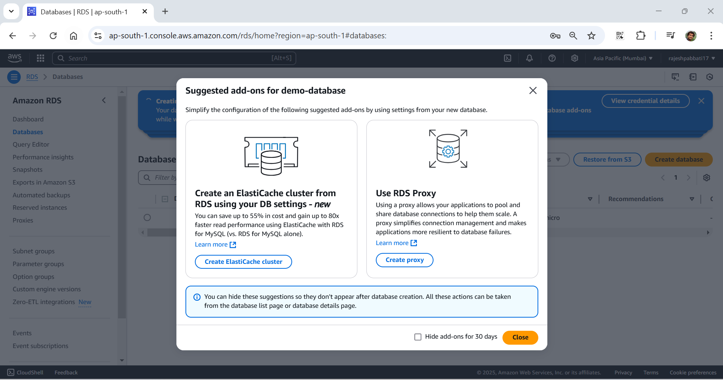

Database is creating

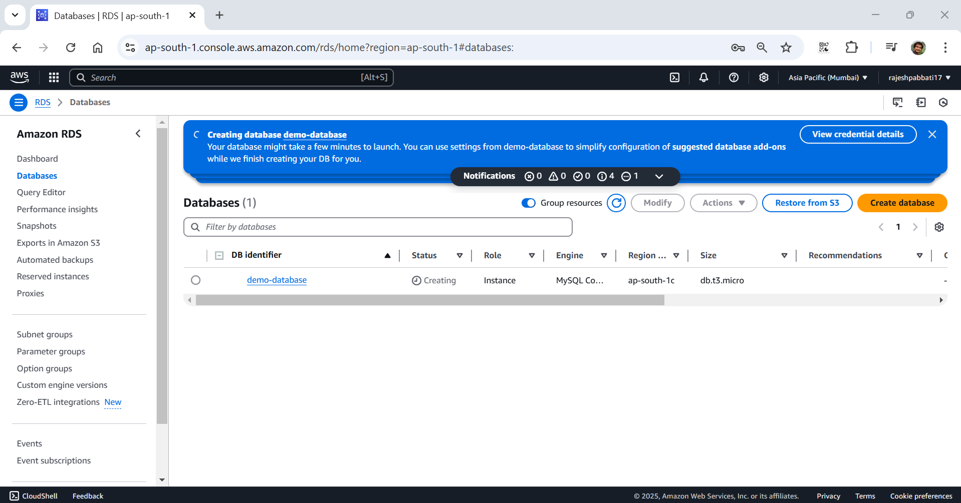

From AWS click on Compute and then click on EC2

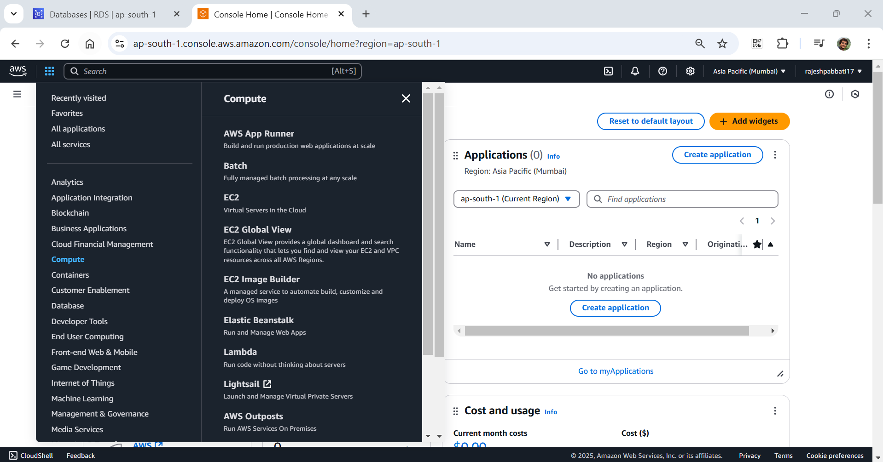

Click on instances and then launch instance

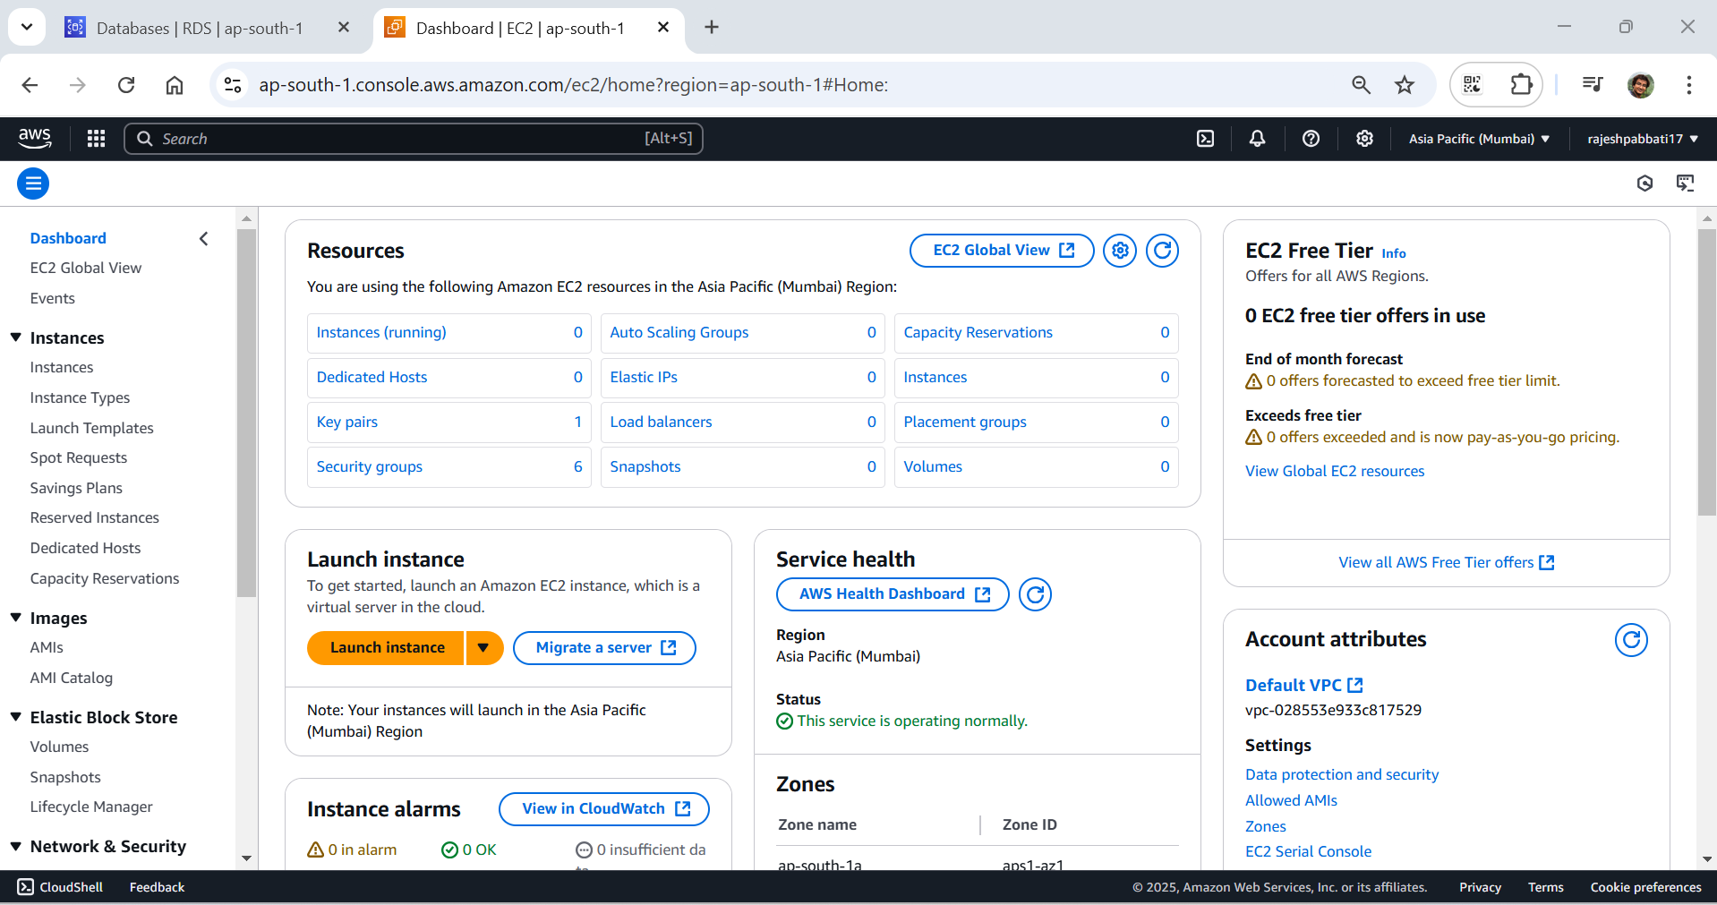

Give name and select unbuntu image

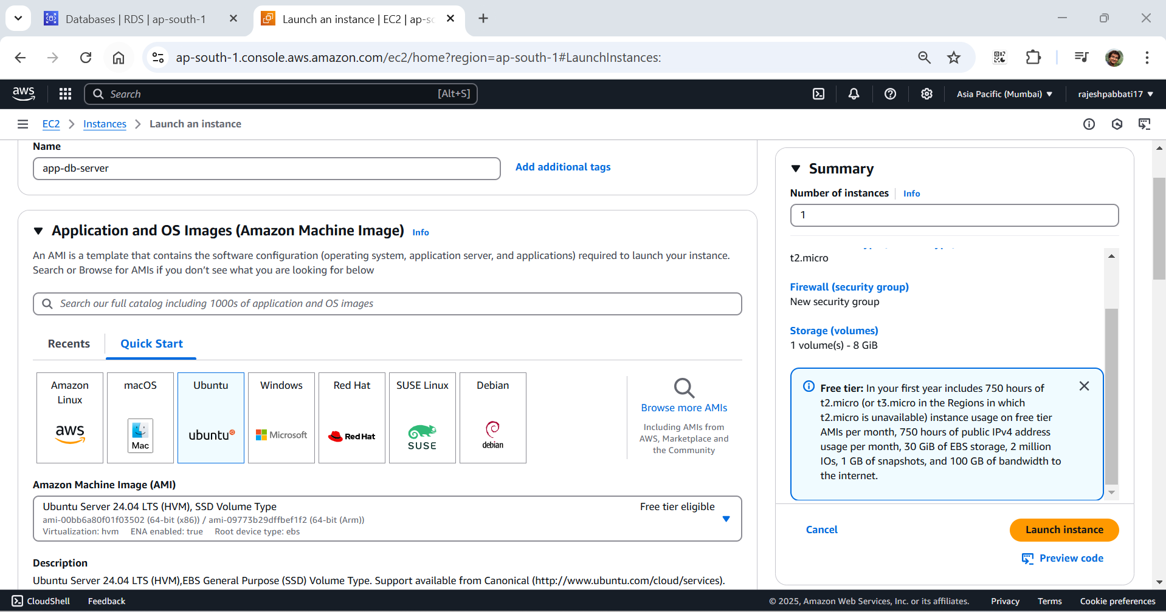

Select key pair and default VPC and default security group and click on launch instance

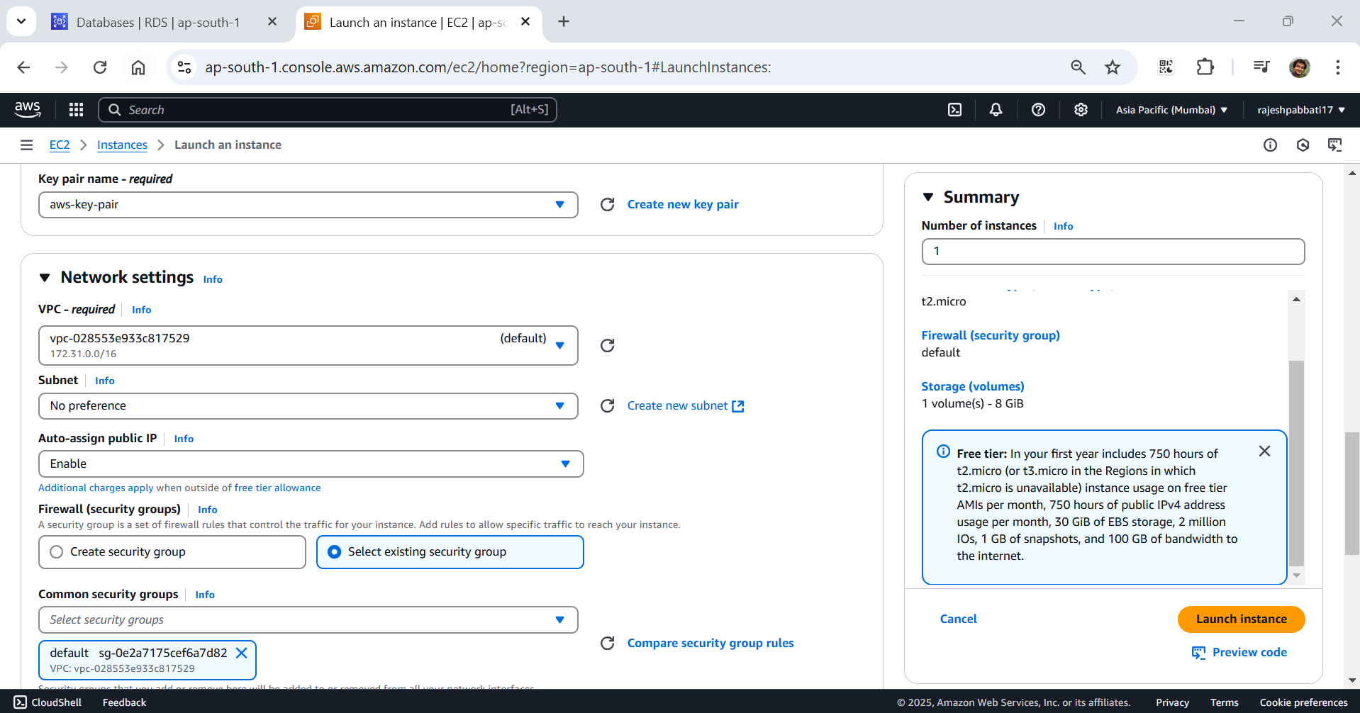

Select instance and click on connect

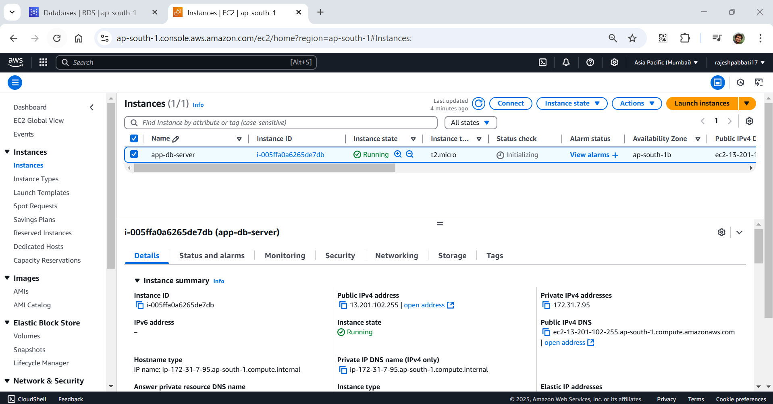

Click on connect

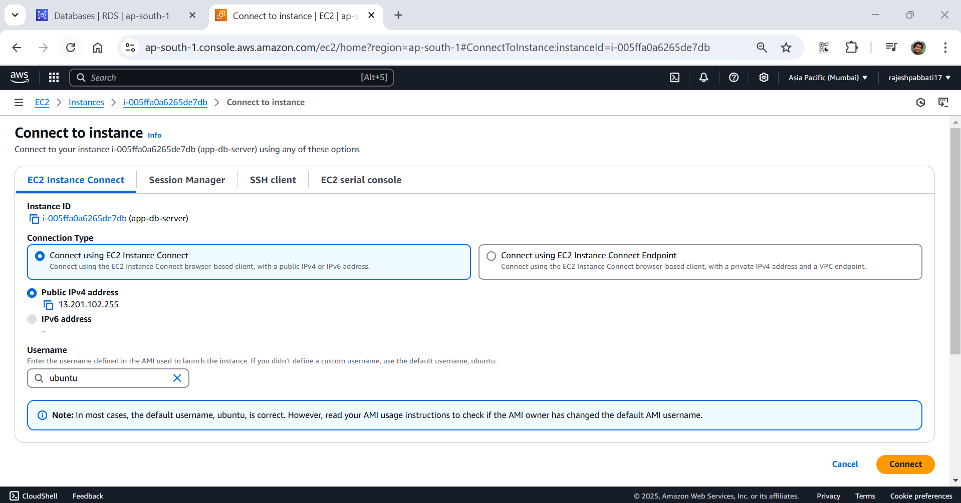

Instance connected enter sudo su command and hit enter

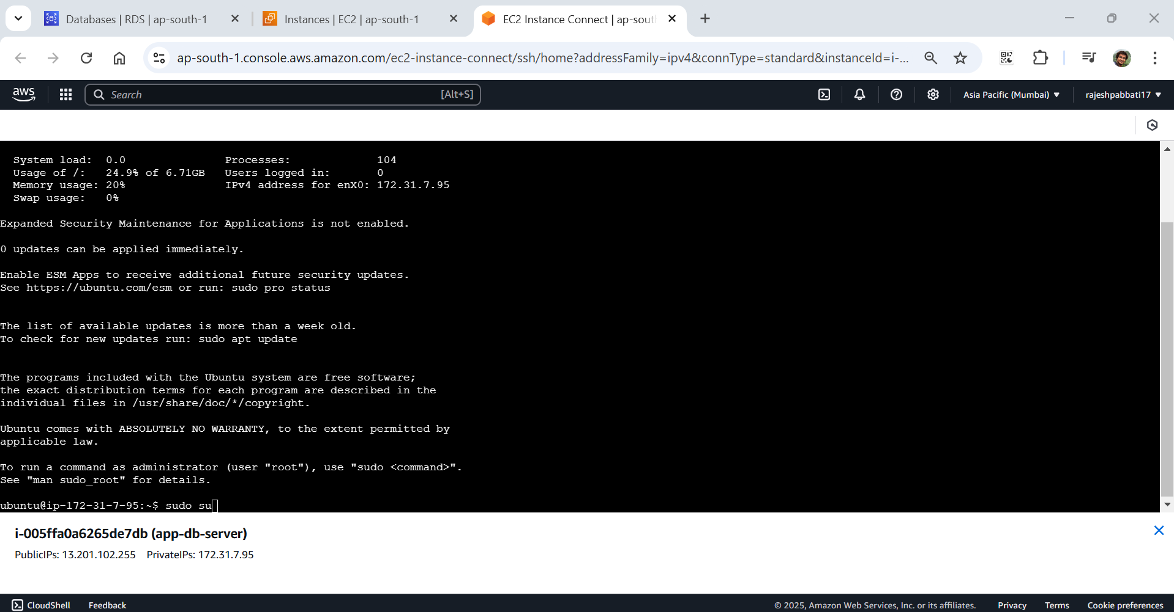

Ener apt update command and hit enter

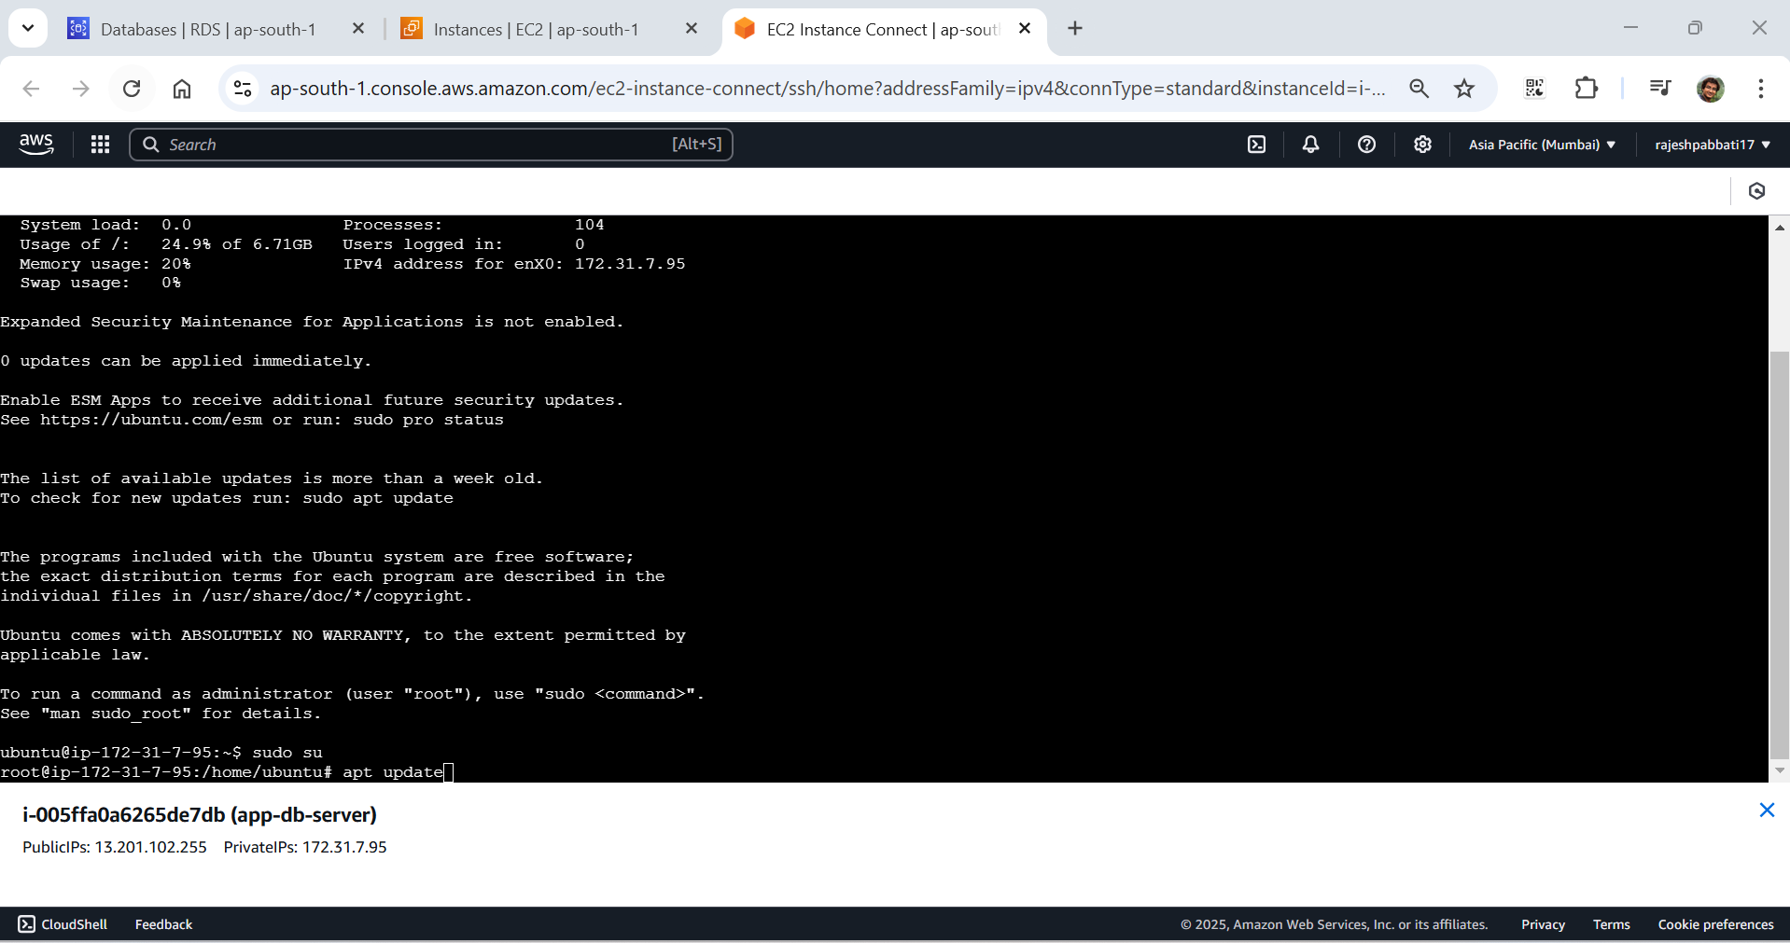

Enter apt install mysql-server -y command and hit enter

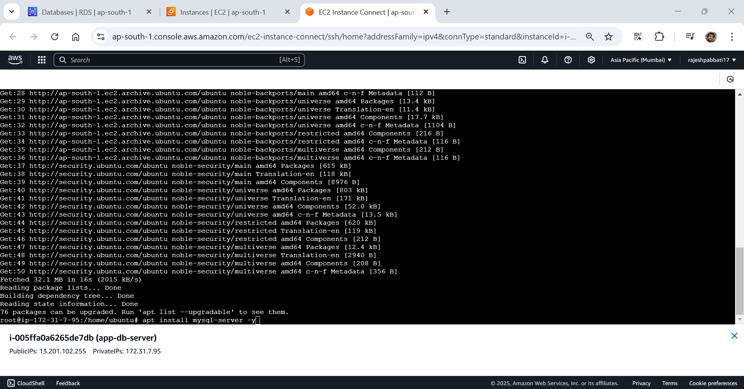

Enter systemctl start mysql.service command and hit enter

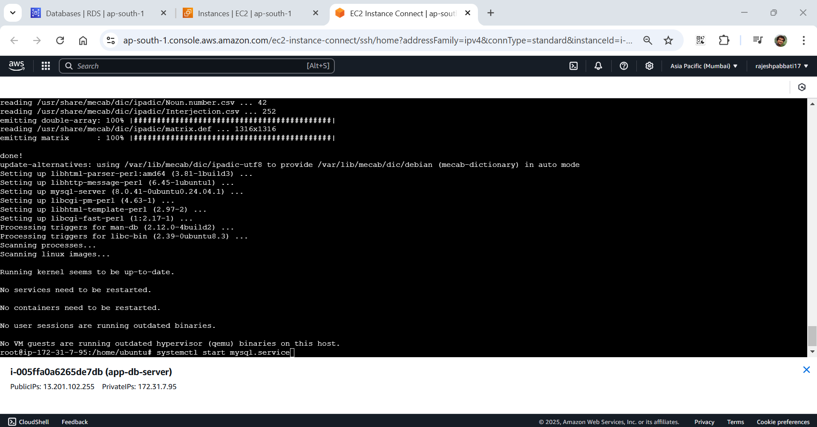

Enter ssytemctl status mysql.service command and hit enter to see service is running

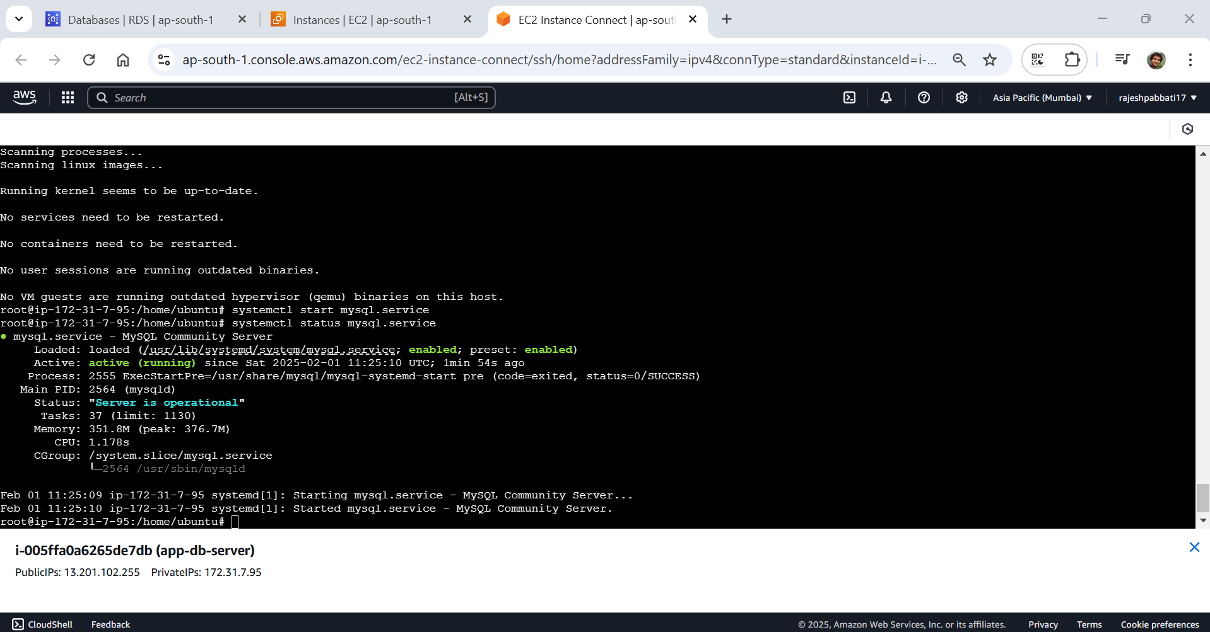

Got to database tab and click on data base demo-database

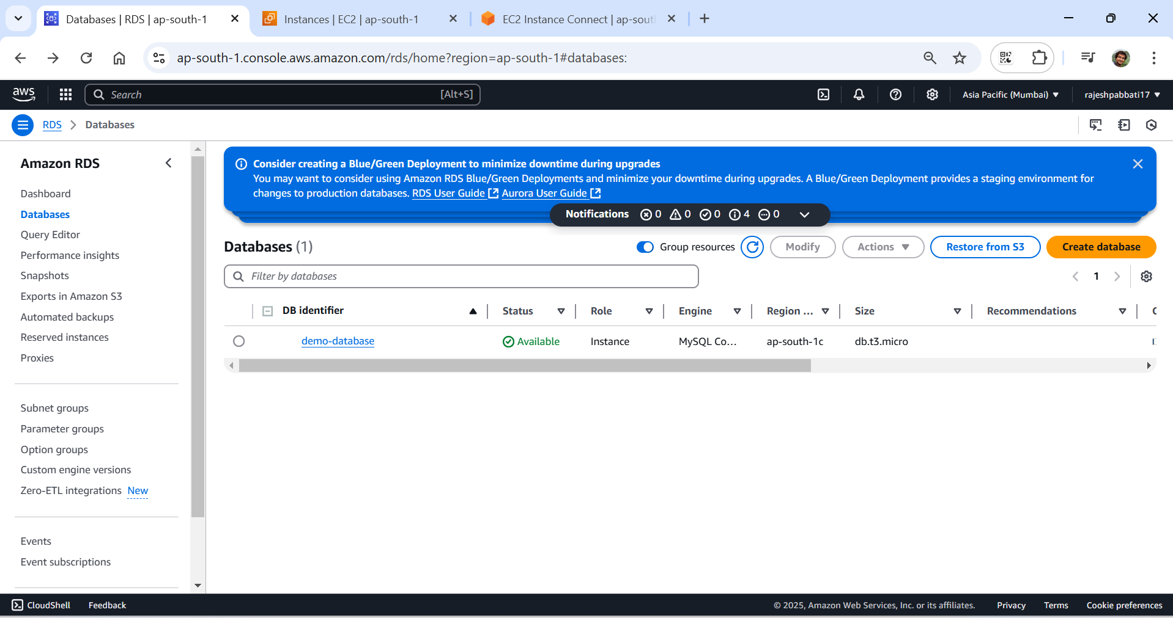

Under connectivity and security copy endpoint

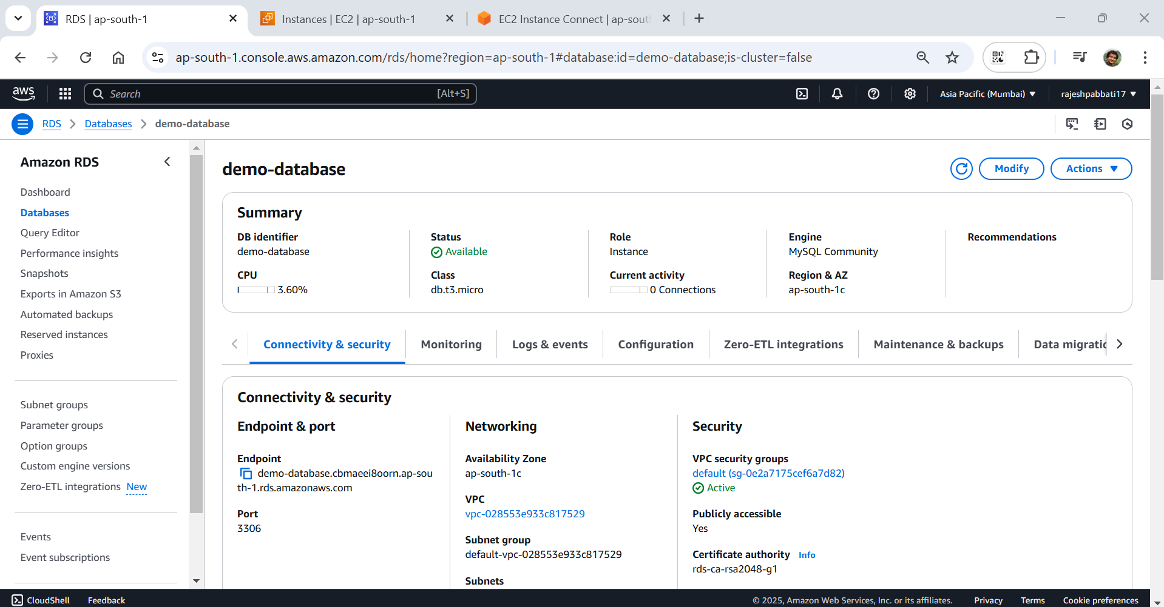

Come to instance tab and enter command mysql -h <paste endpoint here> -P 3306 -u admin -p and hit enter

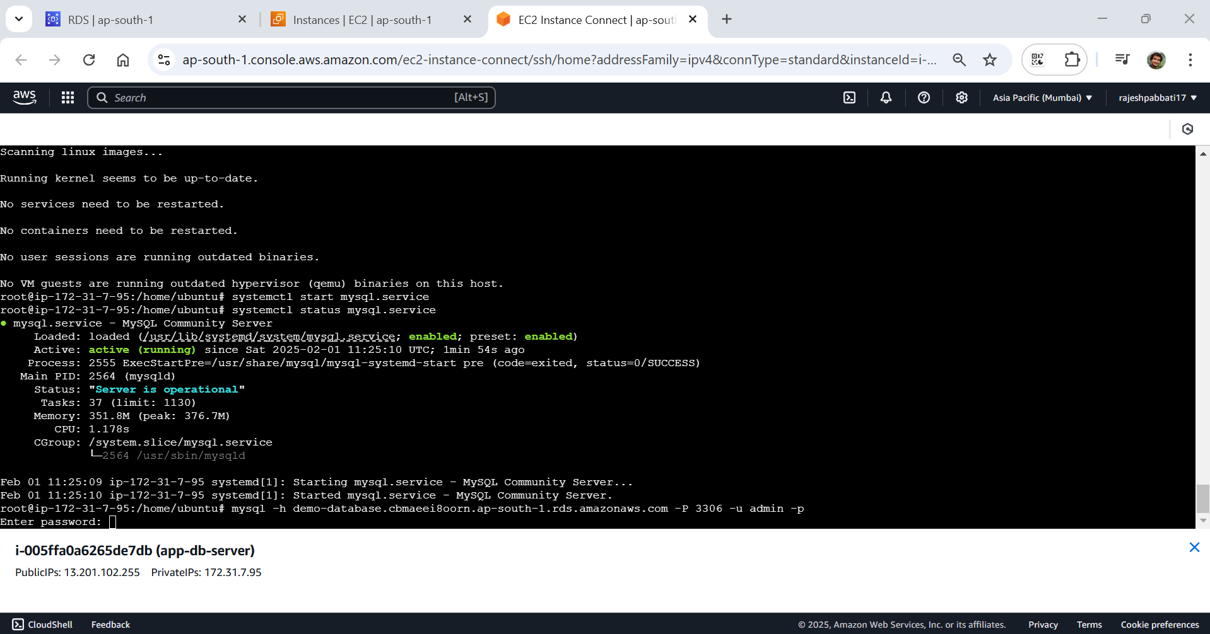

Enter the database password now instance connected to mysql

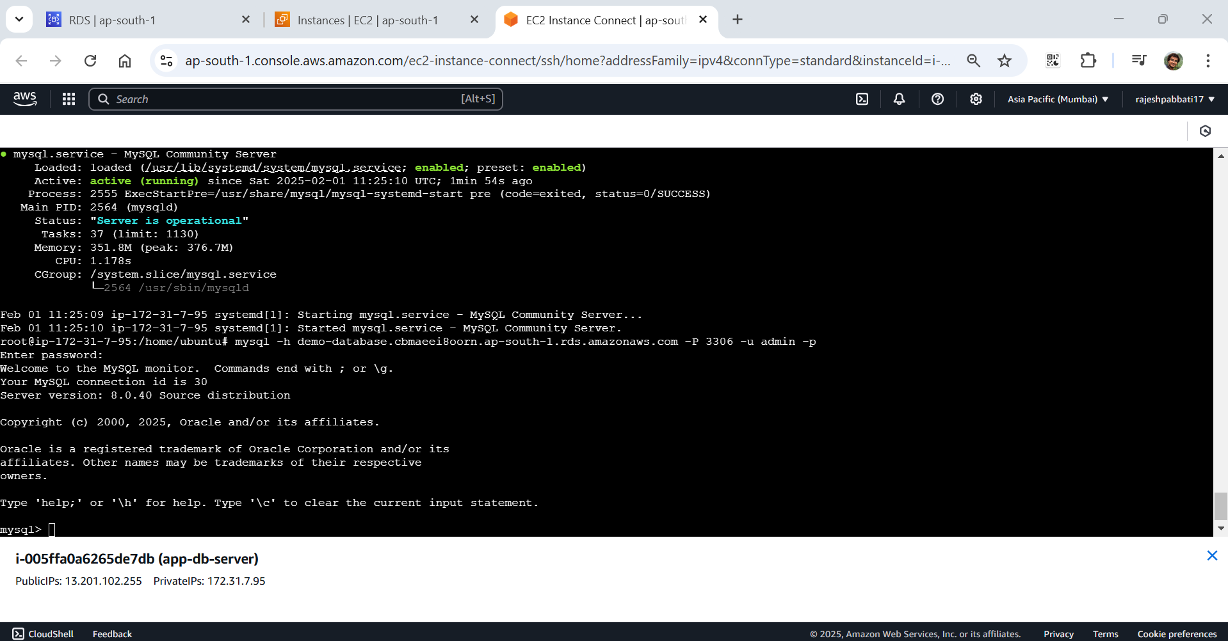

Enter command create database demodb;

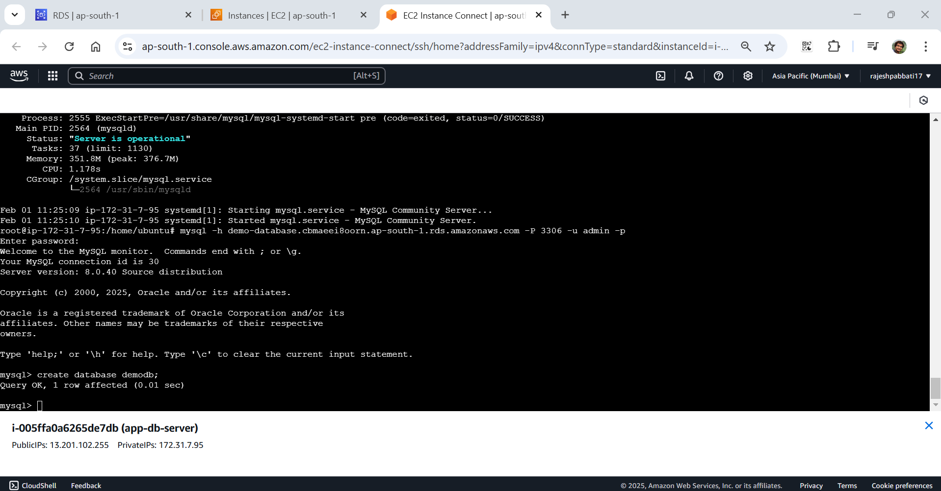

Enter use demodb; command to use enter the schema

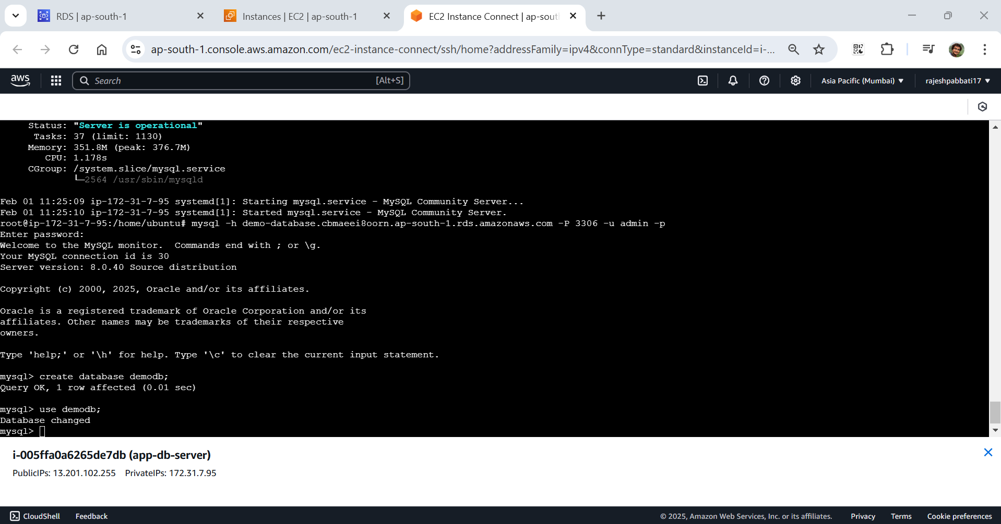

Create table persons using the command in the below screenshot

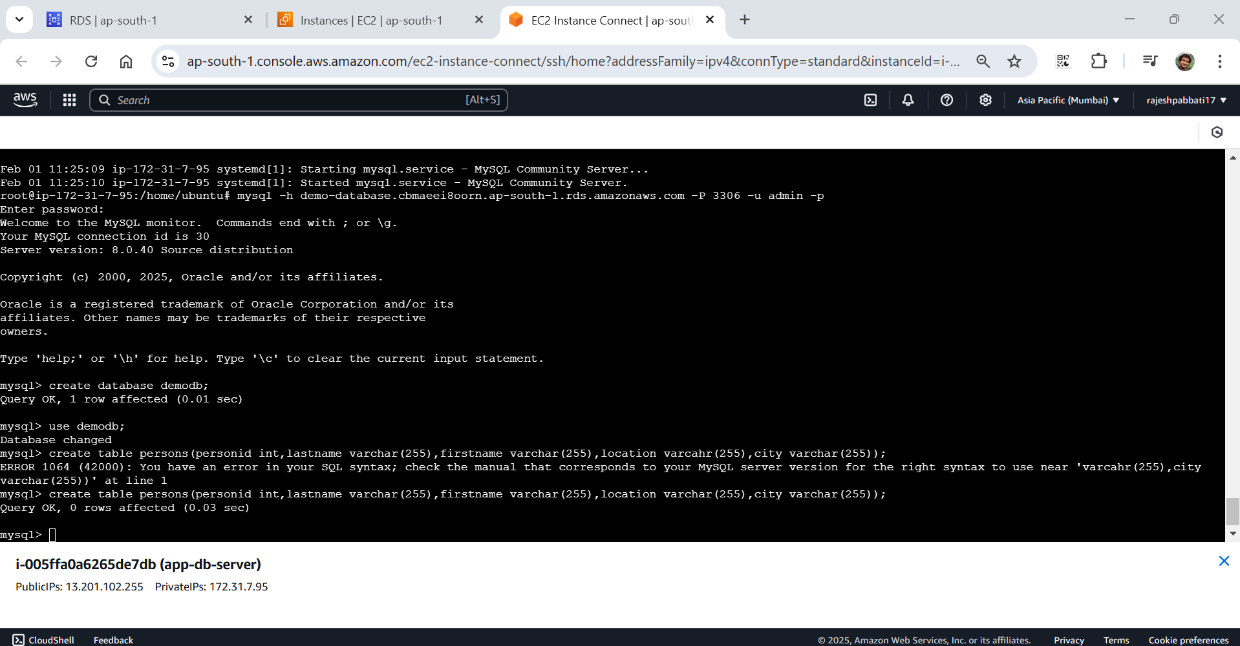

Retrieve values from database using command in the screenshot

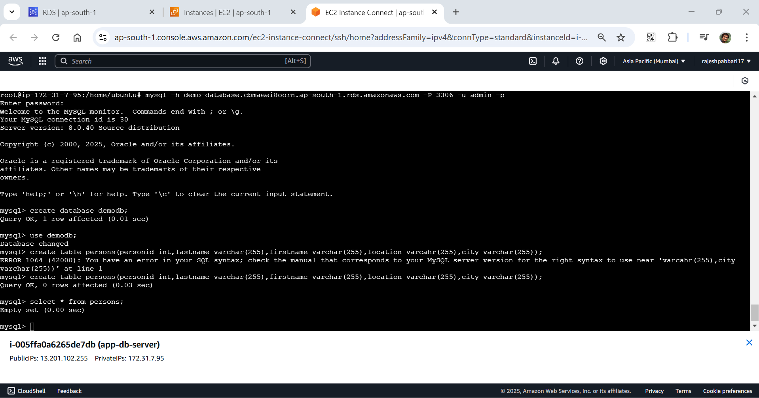

Insert records into table and view the records

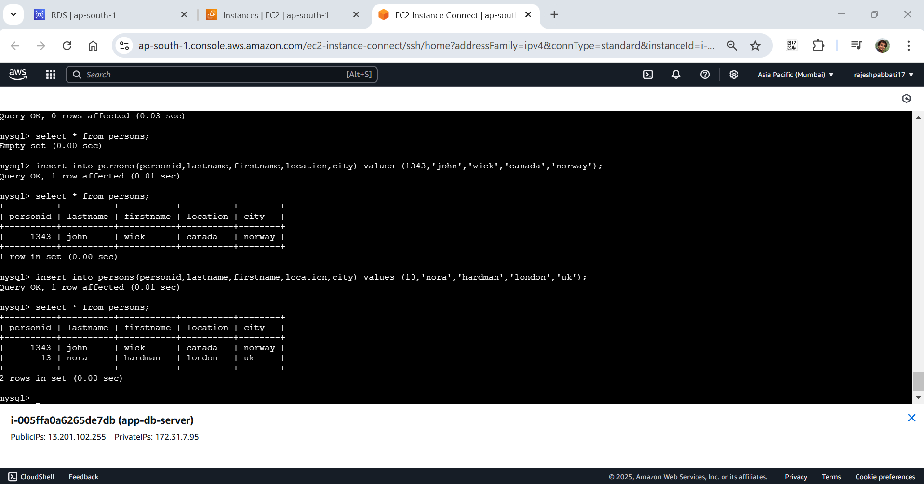

From Aws console go to Database and click on DynamoDB

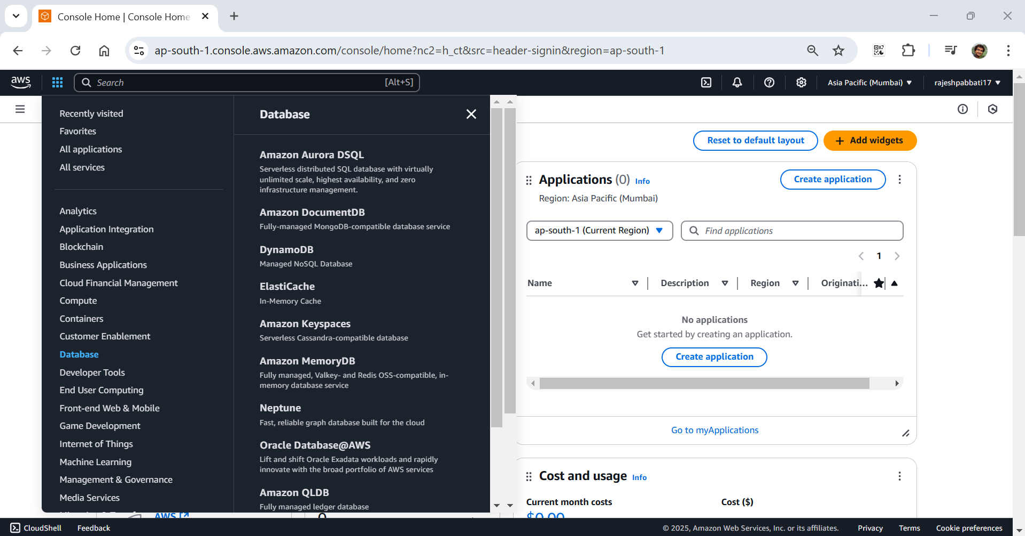

Click on create table

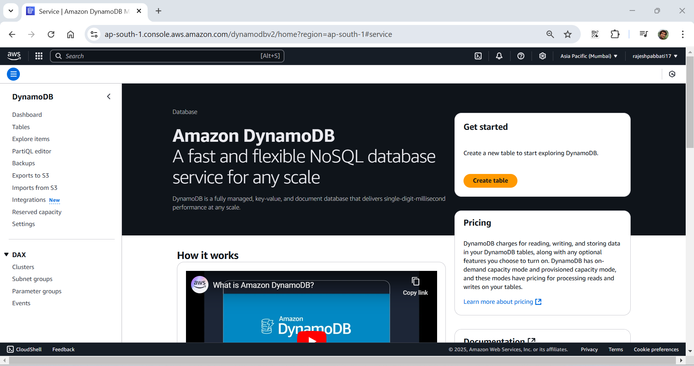

Enter table name and partition key and click on create table

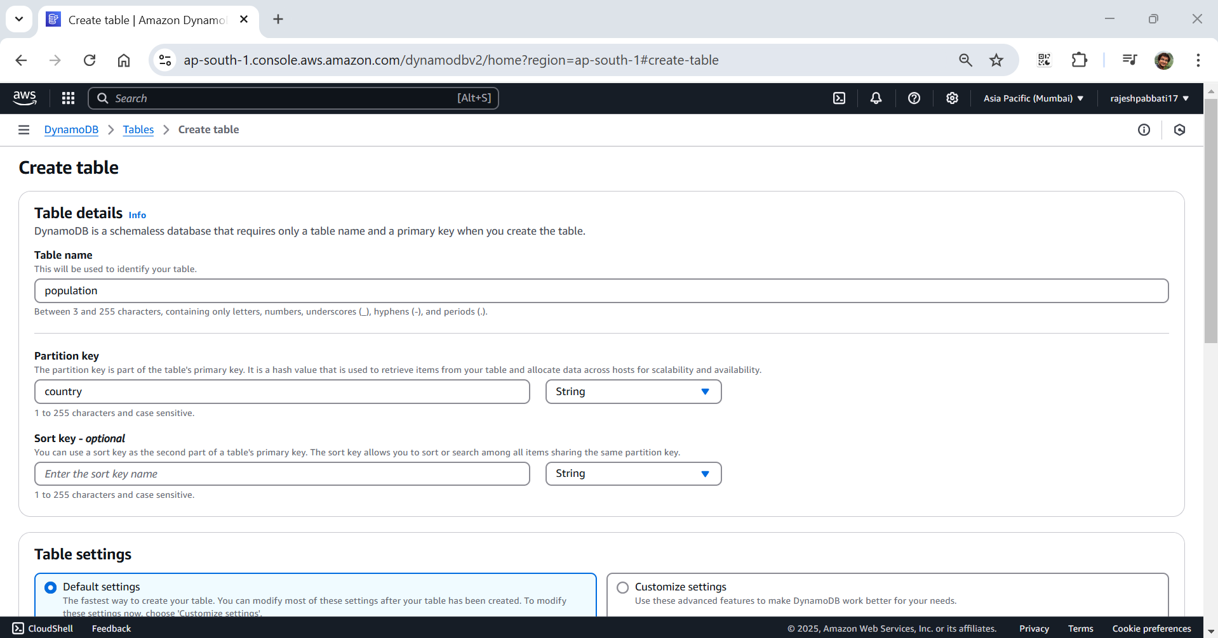

Table is creating

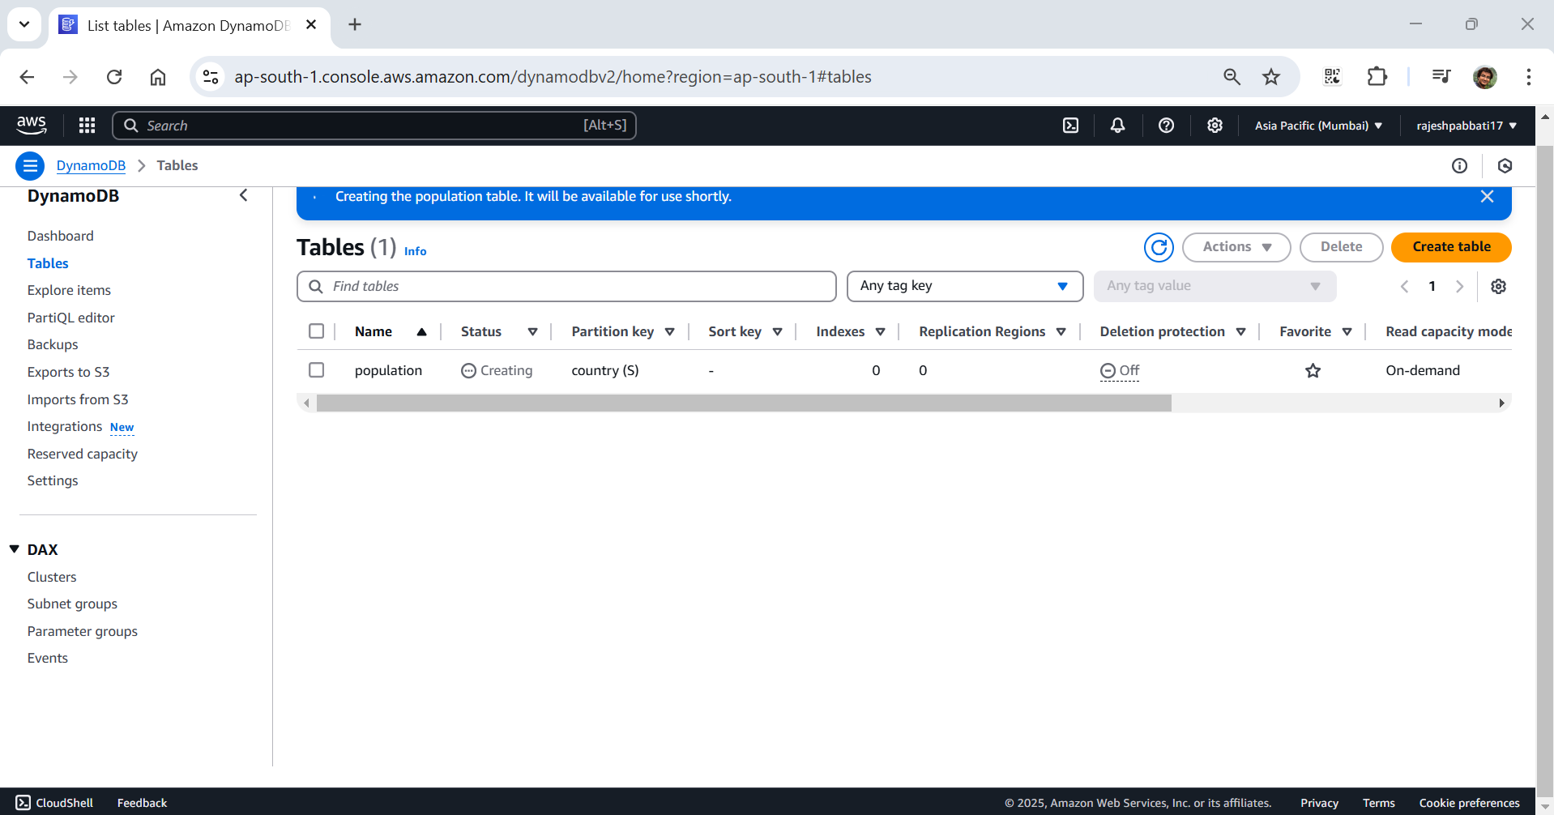

Table created

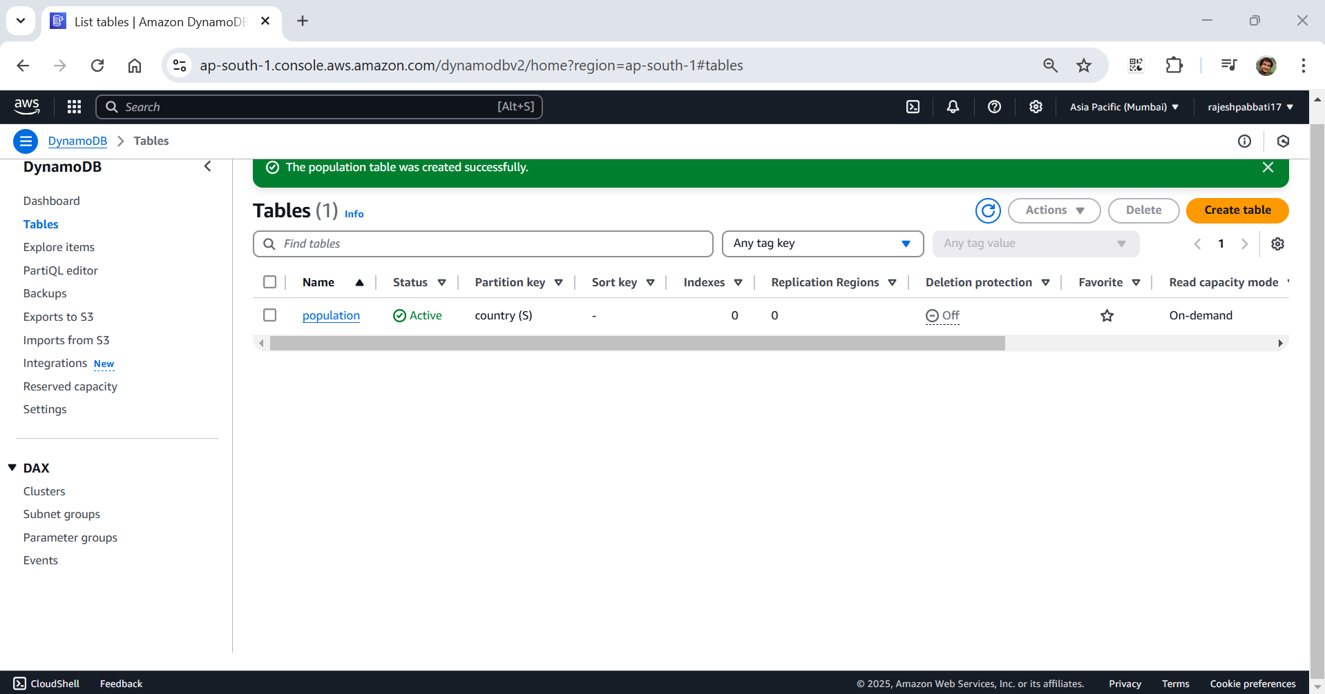

Click on actions then create item

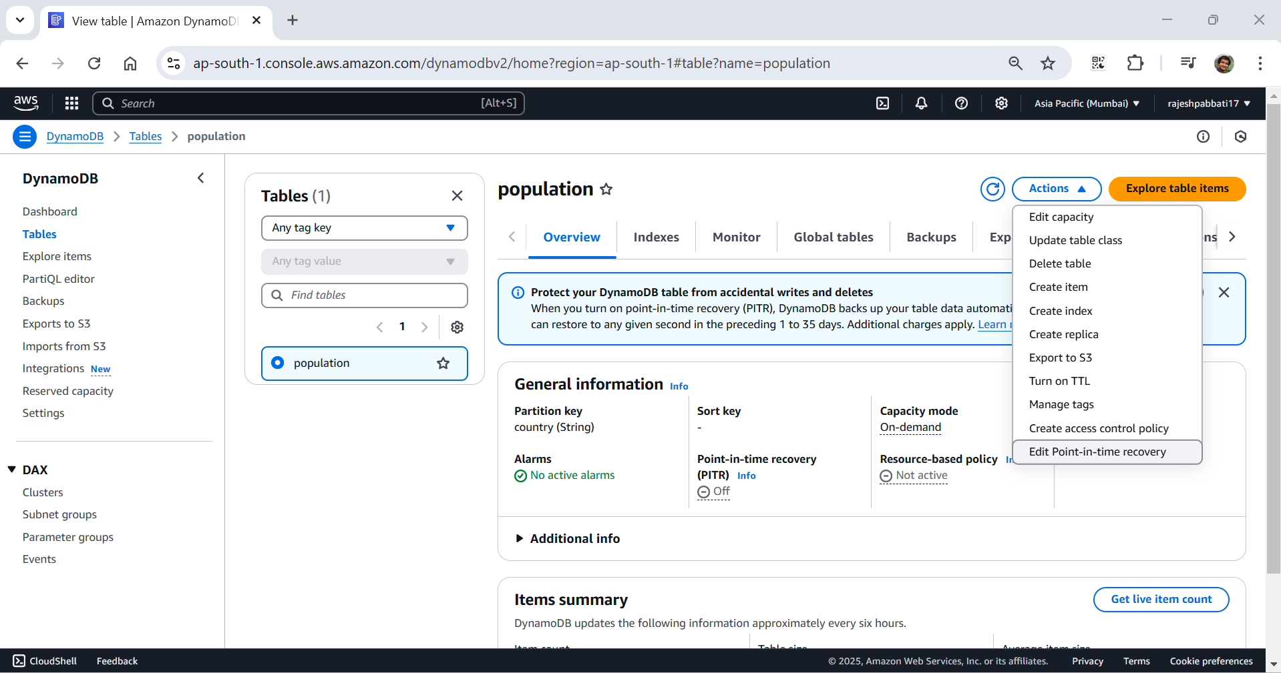

Click on add new attribute and select datatype based on input. Give the key and value and click on create item

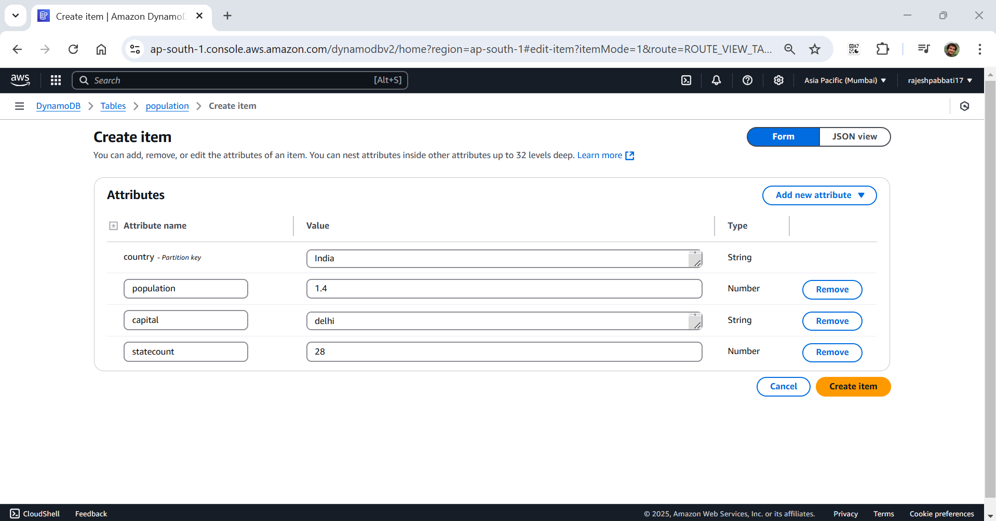

Values are written into table

